NAME:OSAMA KHAN

REG NO:4317-FBAS-BSSE/F21

SUBMITTED TO:SHAKIR RASHEED KHATTAK

**Q1.describe waterfall model of software devolepment and descibe its main stages**

Ans1.***Waterfall Model:***

The waterfall model is a linear, sequential approach to the software development life cycle (SDLC) that is popular in software engineering and product development. The waterfall model emphasizes a logical progression of steps.

The waterfall model is a breakdown of project activities into linear sequential phases, meaning they are passed down onto each other, where each phase depends on the deliverables of the previous one and corresponds to a specialization of tasks. The approach is typical for certain areas of engineering design.

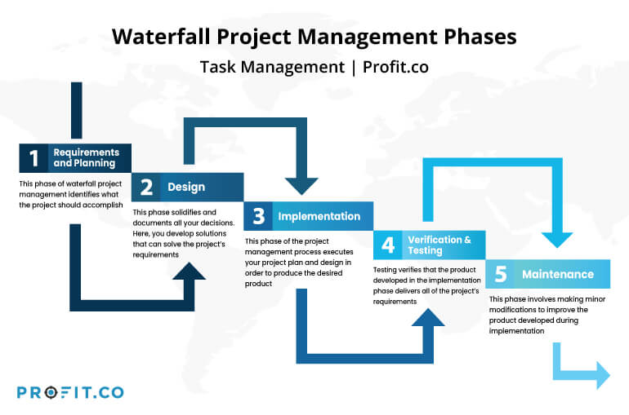

ADVANTAGES AND DISADVANTAGES:

**Advantages::**

1)Before the next phase of development, each phase must be completed.

2)Suited for smaller projects where requirements are well defined

3)Elaborate documentation is done at every phase of the software’s development cycle

**Disatvantages ::**

1)Error can be fixed only during the phase

2)It is not desirable for complex project where requirement changes frequently

3)Documentation occupies a lot of time of developers and testers

**Q2: List stages of software development lifecycle** ,

Answer::Following are the stages of SDLC

1. Planning: In the Planning phase, project leaders evaluate the terms of the project. This

includes calculating labor and material costs, creating a timetable with target goals, and

creating the project’s teams and leadership structure.

2. Define Requirement: Defining requirements is considered part of planning to determine

what the application is supposed to do and its requirements.

3. Designing: Based on the requirements in SRS desired features and operation in detail are

specified and documented in a DDS(Design Document Specification).

4. Development: In this stage of SDLC the actual development starts and the product is

built.The programming code is generated as per DDS during this stage.

5. Testing: This stage refers to the testing of the product where products defects arereported, tracked, fixed and retested, until the product reaches the quality standards defined in

the SRS.

6. Deployment: Once the product is tested and ready to be deployed it is released formally

in the appropriate market.

7. Maintenance: What happens during the rest of software’s life: changes corrections,

additions and more.

**Q3::Write a user level and several system level instructions…..?**

Answer: 1. User level requirement: Proper place given on the screen to enter the book

borrower’s details.

2. System Level Requirements:

⬥ A book must have an ISBN.

⬧ The copy no. of a book must be written on it.

⬧ Status of the book (either available or borrowed).

⬧ Id of the borrower must be given.

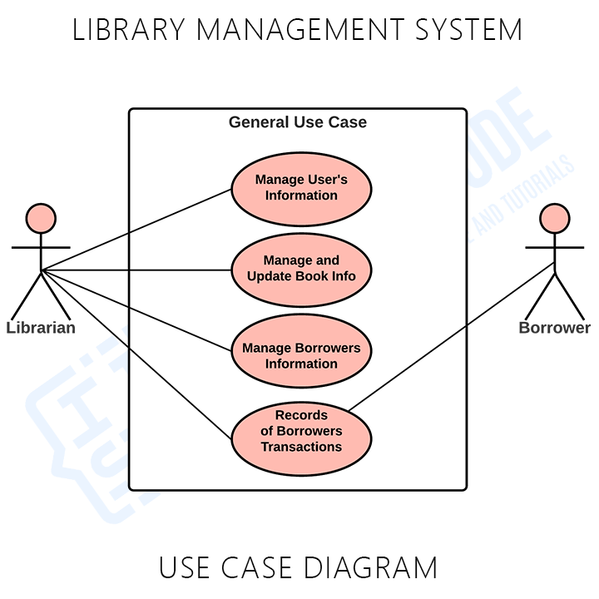

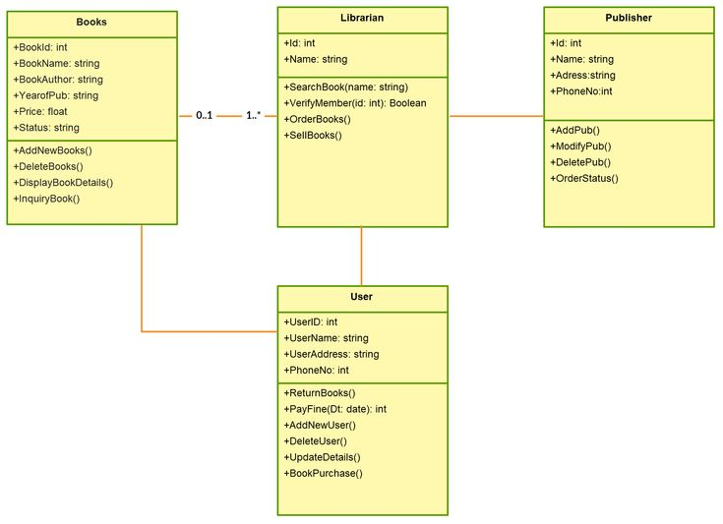

**Q5)Write non-functional requirements for a bike racing game Or online banking** .

Answer**:Bike racing game:**

1. Secure the users acheivements.

2. Secure platform for in game transaction.

3. Ease of use.

4. Good frame rate for every possible low end platform.

5. Performance.

6. Frequent updates to enhance user experience.